**EER DIAGRAM**

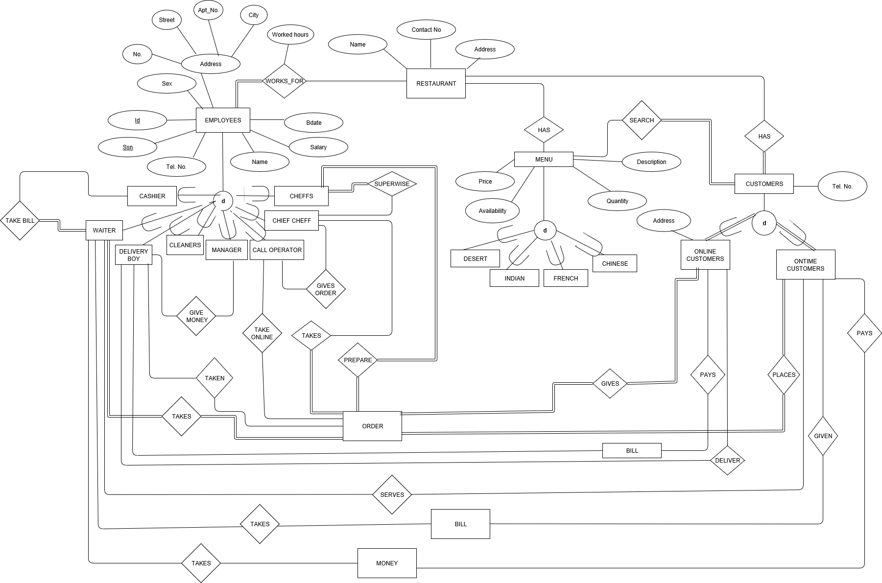

* Restaurant includes three main entities such as employees, menu and customers.

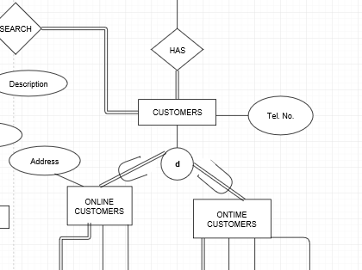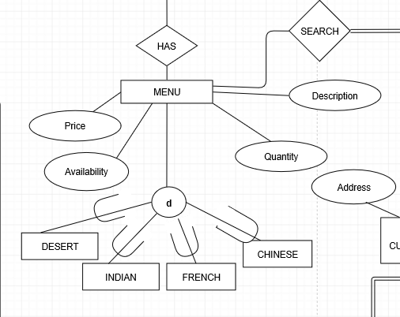

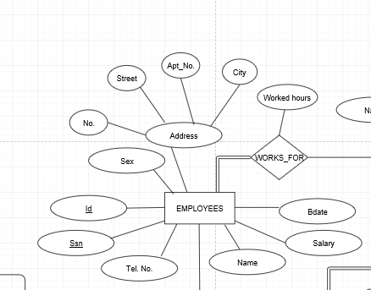

* All the customers will be online or on time
* All the customers will be connect to menu items and employees
* Employees have unique attributes like id and social security number